Steps to creating Air Writing model

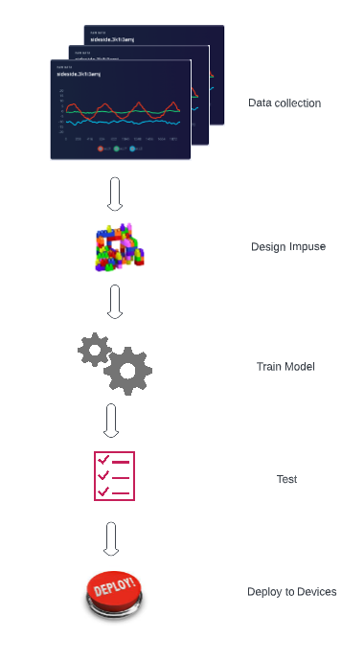

Architecture of Model Training

